 | Composition of materials
Achievement Objective | Technological Knowledge – Technological Products - Level 5  Understand how materials are selected, based on desired performance criteria.
Learning Intention | I am learning.... that materials are selected for specific technological outcomes on whether their performance properties match the desired outcomes specifications and that this knowledge comes from understanding how the material is made.  This will help me to select materials that meet the desired performance properties for my own outcome.  - Materials are made of smaller parts, composite parts to enhance properties for a particular use  - Materials are made from a combination of different types fibres
Activity Instructions | Composition and Properties of Materials; What is the material composed of to create the performance properties?  - Brainstorm the given technological outcomes; what are the physical conditions of the sport, the environment, constraints etc.  - List the desired material properties for a garment for diving and competitive swimming.  - Research into Neoprene and Fastskin.  - List the material properties.  - Suggest other uses.
Teacher Notes

Fabrics for water |  | 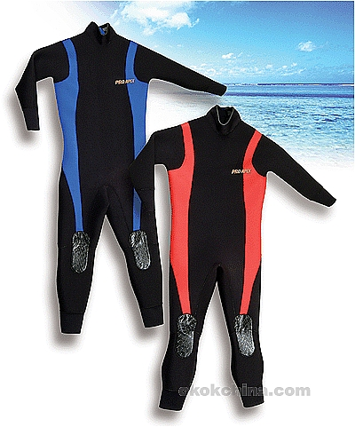  Wetsuit  Neoprene | 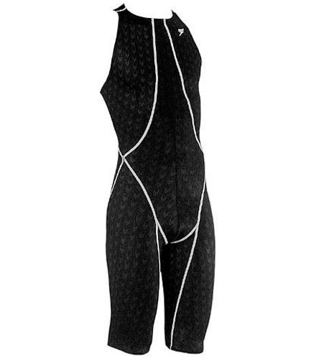  Competitive swimwear  Fastskin
List the performance criteria for the activities.

Match the performance properties of the selected materials with the desired performance criteria.

Identify the composition of the material

Suggest other uses for the material based on its properties.

ANSWERS...

Fabrics for water sports  Brainstorm the activities; what are the physical conditions of the sport. |  | Diving Wetsuit  Neoprene | Competitive Swimwear  Fastskin
List the performance criteria for the activities. | - Warm  - Comfortable  - Helps with diving  - Won’t rip easily  - Mobility in water  - Must not degrade from sun  - Salt resistant  - Stretch to fit  - Easy to get into |  | - Snug fit  - Easy to put on  - No water drag  - Allow for great speed  - Modesty!  - Comfortable  - Not transparent  - Light
Match the performance properties of the selected materials with the desired performance criteria.  Is this the optimal material for this activity?  Research | - Maintains flexibility for movement  - Buoyant  - Compresses under water pressure  - Physical toughness  - Does not burn  - Flexibility and twisting do not damage it  - Resists tearing  - Fire resistant  - Weather and salt proof |  | - Light weight  - Great stretch  - Low surface friction drag  - Water repellent  - Quick drying  - Chlorine resistant  - Stretch and shape retention
Identify the composition of the material | Synthetic rubbers produced by polymerisation of chloroprene. Foamed neoprene contains gas cells – great for insulation and shock protection. Nylon & spandex backing helps to make it easier to put on and more comfortable against the skin. |  | Elastane/ultra fine nylon thread, water repellent fabric, woven-chlorine resistant Elastane and ultra fine nylon yarn.
Suggest other uses for the material based on its properties.

Swimwear

High-technology swimwear fabrics are scientifically advanced materials used for swimwear in competitive water sports such as swimming and triathlon. Materials of this type are normally lycra and nylon composite fabrics with features to reduce drag against the water. The fabrics include features that increase the swimmer's glide through the water (said to mimic marine animal skin) and reduce the absorption of water by the suit as opposed to regular swimsuits.

Some companies claim that their fabrics reduce drag even more than the water's normal friction against the skin. To do this they design high-end lines of competitive swimwear that cover the arms and legs.

High-tech fabric lines by swimwear manufacturer:

* Speedo - Aquablade, Fastskin, Fastskin 2, Fastskin PRO and LZR Racer
* Nike - LiftSuit
* Diana - Submarine
* Arena - Powerskin, Powerskin Xtreme and Powerskin R-Evolution, Arena X-Glide
* Adidas - JetConcept, Hydrofoil
* Tyr - Fusion, Aquapel, Aquashift and Tracer
* Jaked - 01

Whether high-tech fabric lines such as these give substantial advantages to swimmers is heavily debated. For example, Speedo claims their lineup will increase one's swimming velocity by 3–7%.[citation needed] Their most popular suit, the Fastskin, is worn by most Olympic swimmers and increases speed by reducing drag by up to 4%. It is meant to resemble shark's skin; therefore, it has tiny triangular projections that point backward so that the water spirals off the athlete's body. A 2000 study, by Joel Stager of Indiana University's Counsilman Center for the Science of Swimming, reportedly found an increase of only 0.34%. Most of the manufacturers counter with their own studies though touting the advantages of their own individual lines overall and against their competitors.

The materials are sometimes very expensive ($300–$600 US for a full suit), limiting their use to highly competitive and professional levels of the sport. However, in recent years with the advance of technology the most basic 'high-technology swimwear' can be purchased for approximately $100.
From Wikipedia

Fastskin

Speedo announced the launch of the Fastskin FS-PRO swimsuit in 2007, the fastest and most powerful lightweight swimsuit ever made.

Developed in the Speedo Aqualab, the brand’s research and development headquarters, the Fastskin FS-PRO was engineered in response to feedback from athletes and coaches who were looking for a suit that had all the speed and compression of Speedo’s Fastskin and FSII but in a lightweight fabric. Tests have shown the Fastskin FS-PRO suit to have the lowest passive drag results of any lightweight woven suit on the market, helping athletes move even faster through the water.

Key features of the Speedo Fastskin FS-PRO include:
* Lightweight and powerful stretch
* Superior compression compared to other woven light suits
* Improved core stability compared to other woven light suits
* Improved fit through computer modeling and engineering
* Lower surface friction drag at a fabric level compared to other woven fabrics
* Lower overall passive drag compared to other light suits
* Water repellent and quick drying

Fabric
The Fastskin FS-PRO features new water-repellent fabric exclusive to Speedo: LZR Pulse. This lightweight fabric is woven from chlorine resistant elastane and ultra fine nylon yarn. In tests, the suit proved to have the lowest water absorption rate of woven fabrics allowing for a lighter feel and greater speed in the water. As the quickest drying woven suit on the market, the Fastskin FS-PRO offers superior comfort both in and out of the water.

* A high densiity microfiber fabric woven from chlorine resistant elastane and ultra fine nylon thread
* 15 % more powerful compression than any other lightweight suit on the market
* Significantly improved stretch and shape retention Water repellent coating limits water absorption resulting in a long lasting durable fabric
* Unique water repellent coating bonded to the LZR Pulse fabric via patented plasma process
* Bonding process produces durable and long lasting water repellent finish
* Limited water absorption creates an incredibly lightweight feel in the water
* Quick drying fabric enhances performance over multiple same day swims

Compression
The Fastskin FS-PRO provides the athlete with improved core stability during strokes and reduces energy loss through reduced muscle oscillation. The new suit also offers greater compression by area – meaning it exerts more power in a single square of fabric than other fabrics when tested – than any other lightweight suit.

* Significantly greater fabric power and compression than any other lightweight suit on the market
* Compression provides core stability and firmness during competition without feeling restrictive or heavy
* Improves muscle efficiency through reduction of excess muscle vibration

Engineered in 3D
The Fastskin FS-PRO was designed using data gained from the body scans of hundreds of elite international swimmers. The testing and analysis included a highly sophisticated process called Computational Fluid Dynamics (CFD) enabling Speedo to virtually analyze the drag and flow of water around swimmers and, in effect, create a virtual swimmer inside a computer.

* Seams vertically oriented to reduce drag based on CFD analysis (Computational Fluid Dynamics)
* Fit engineered from body scan data of hundreds of elite swimmers resulting in an optimum biomechanic fit
* Seams reinforced through innovative sewing process

In addition to working with some of the world’s top athletes, such as Phelps and Australia’s Grant Hackett, the Aqualab® team at Speedo enlisted the expertise of worldwide specialists to design the Fastskin FS-PRO. The development team included: Barry Bixler, Computer Fluid Dynamics Analysis (CFD), Dave Pease for flume testing at Otago University in New Zealand, and Rick Sharp, Swim Physiologist.

http://video.msn.com/?mkt=en-us&brand=msnbc&vid=805945ad-6c04-4a60-abe9-425fe9ecb00a

What do you think? Does the suit give swimmers an unfair advantage?

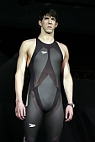

Neoprene

Diving suits
# Made of high flexible neoprene rubber coated with nylon jersey or lycra spandex.
# Double blind stitched for durability and watertight seams
# One-piece wet suit model with back zipper.
# YKK anti-rust zipper
# O-ring seal at neck and cuffs helps keep water out.
# Skin-in seal an back zipper and ankle zippers with sealing gussets.

Neoprene or polychloroprene is a family of synthetic rubbers that are produced by polymerisation of chloroprene.[1] Neoprene in general has good chemical stability, and maintains flexibility over a wide temperature range. It is used in a wide variety of applications, such as laptop sleeves, orthopaedic braces (wrist, knee, etc.), electrical insulation, liquid and sheet applied elastomeric membranes or flashings, and car fan belts.

A foamed neoprene containing gas cells is used as an insulation material, most notably in wetsuits. Foamed neoprene is also used in other insulation and shock-protection (packing) applications.

Neoprene is the DuPont trade name for its brand of polychloroprene

For diving and exposure protection applications, neoprene is manufactured by foaming the plastic with nitrogen gas, for the insulation properties of the tiny enclosed and separated gas bubbles (nitrogen is used for chemical convenience, not because it is superior to air as an insulator). The foam cells thus created also make the material quite buoyant, and the diver must compensate for this by wearing weights. Thick wet suits made at the extreme end of their cold water protection are usually made of 7 mm thick neoprene. It should be noted that since foam neoprene contains gas pockets, the material compresses under water pressure, getting thinner at greater depths; a 7 mm neoprene wet suit offers much less exposure protection under one hundred feet of water than at the surface. A recent advance in neoprene for wet suits is the "super-flex" variety, which mixes spandex into the neoprene for a greater flexibility.

As a result wetsuit neoprene sheet is manufactured in different grades dependant on the application. Diving suit neoprene is denser and less flexible; this ensures its durability and reduces compression at depth. Sailing wetsuits are never exposed to large compressive forces so contain more gas, so are warmer for the same thickness. Competitive swimming wetsuits are made of the most expanded foam; they have to be very flexible to allow the swimmer unrestricted movement. The downside is that they are quite fragile.
Source Wikipedia

A Balanced Combination of Properties

* Resists degradation from sun, ozone and weather
* Performs well in contact with oils and many chemicals
* Remains useful over a wide temperature range
* Displays outstanding physical toughness
* Resists burning inherently better than exclusively hydrocarbon rubbers
* Outstanding resistance to damage caused by flexing and twisting

Neoprene is a synthetic rubber with a wide variety of uses. As a fabric, neoprene often has a nylon or spandex backing on one or both sides to make it easier to put on and more comfortable against the skin. Since neoprene can be a difficult fabric to work with, most neoprene products are commercially manufactured using special sewing and seam-sealing techniques.

History
1. DuPont laboratories invented in neoprene in 1930, based on the work of chemistry professor Julius Arthur Nieuwland. The professor's research on developing synthetic rubber led DuPont scientists to create a polymerised version of chloroprene, or polychloroprene. DuPont originally named its new polychloroprene material DuPrene but changed the name to neoprene in 1936. A variety of engineers and inventors began using neoprene for wetsuits in the early 1950s.
Function
2. One of the best known uses for neoprene fabric is for wetsuits in scuba diving. Neoprene is also commonly used in wading boots for fishermen since it protects the skin from cold water. Laboratory workers may use neoprene gloves to protect their hands from acids, chemicals, solvents and oils. Kayakers and people who participate in cold-weather activities may also wear waterproof neoprene gloves, sometimes lined with fleece, to protect their hands from cold water, ice and snow. Many medical support braces, such as those for ankles, wrists and knees, also use neoprene.
Size
3. Neoprene fabric comes in a variety of thicknesses, generally ranging from 2 to 5 millimetres. Neoprene waders are often made from 5 mm neoprene, while cold-water wetsuits may use neoprene fabric up to 7 mm thick. The thicker the neoprene, the better it insulates from the cold. In contrast, neoprene suits for competitive swimmers may use fabric as thin as 1 mm in areas that need to be extremely flexible, such as under the arms. Suppliers such as Seattle Fabrics, linked below, sell neoprene fabric by the square foot or in sheets that measure 51 by 82 inches.
Benefits
4. Neoprene fabric is durable and flexible and resists tearing. It can also withstand cold temperatures as well as exposure to the sun. Neoprene fabric contains air pockets that provide excellent insulation for wetsuits, cold-wear gear and lunchboxes and beverage coolers. Neoprene is also chemically inert and resists oils, making it useful for protection while handling chemicals. Since neoprene is more fire resistant than most rubbers, it can also be used in combat gear.

From:
http://www.ehow.com/about_4608813_neoprene-fabric.html

