 | Product Flops
Achievement Objective | Technological Knowledge – Technological Modelling - Level 4  Understand how different forms of functional modelling are used to explore possibilities and to justify decision making and how prototyping can be used to justify refinement of technological outcomes.
Learning Intention | I am learning... that technological modelling helps technologist to make decisions and improve their outcomes
Activity Instructions | - Read about a product that failed  - Identify possible reasons why this product failed?  - How could technological modelling have lessened this product failure?  Consider...  - What functional models could have helped the technologist?  - What information did the technologist not find out?  - When were the key times when decisions were made?  - What testing or trialling could have been done?  - How could prototyping have helped?  - What technological modelling would be needed to re-launch this product?
Teacher Notes | - Encourage students to identify product flops that they are familiar with.  - Discuss students own past or current technological practice.

Clairol's
Touch of Yogurt Shampoo
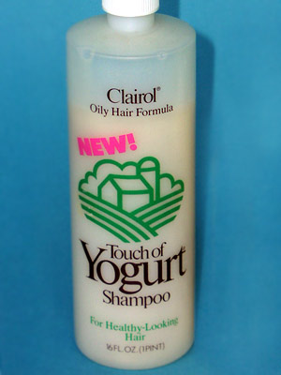
The shampoo failed to attract consumers (in 1979) largely because nobody liked the idea of washing their hair with yogurt. Of those who did buy it, there were even some cases of people mistakenly eating it, and getting very ill as a result. The "Touch of Yogurt" concept is made even more remarkable because three years earlier Clairol introduced a similar shampoo called the "Look of Buttermilk." This product instantly bombed in test markets where consumers were left asking: what exactly is the "look of buttermilk" and
why should I want it?

Cocaine Energy Drink
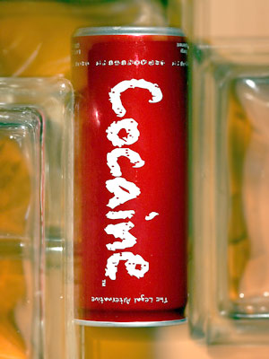
Cocaine is a high-energy drink, containing three and a half times the amount of caffeine as Red Bull. It was pulled from U.S. shelves in 2007, after the FDA declared that its producers, Redux Beverages, were "illegally marketing their drink as an alternative to street drugs." The drink is still available, however, online, in Europe and even in select stores in the U.S. Despite the controversy, Redux Beverages does not plan to cease production any time soon. You know what they say -- there's no such thing as bad publicity.

Pepsi A.M. and Crystal Pepsi
In the late 1980s, Pepsi came up with the brilliant plan to cater to the breakfast cola drinker, under the assumption that because Pepsi contained caffeine, it must be a natural substitute for coffee. Pepsi AM was not successful, and neither was Pepsi's later foray into clear cola, Crystal Pepsi. Apparently, when it comes to cola, the consumers know what they want -- they want it brown, and they want to drink it all day long.

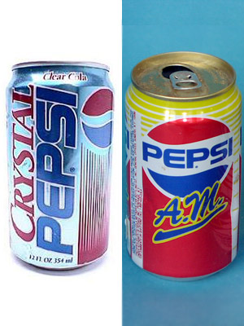

Bottled Water for Pets
People tend to pamper their pets, so it's not far-fetched to believe consumers might serve bottled water to their cats and dogs. At least that's what the makers of Thirsty Cat! and Thirsty Dog! must have believed. But despite the fact that the water came in such delicious flavours as Crispy Beef and Tangy Fish, it never seemed to catch on.
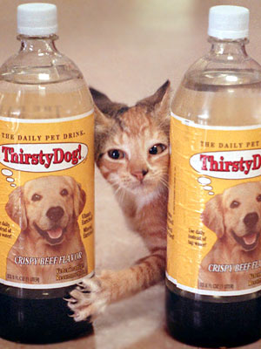

The Sinclair C5
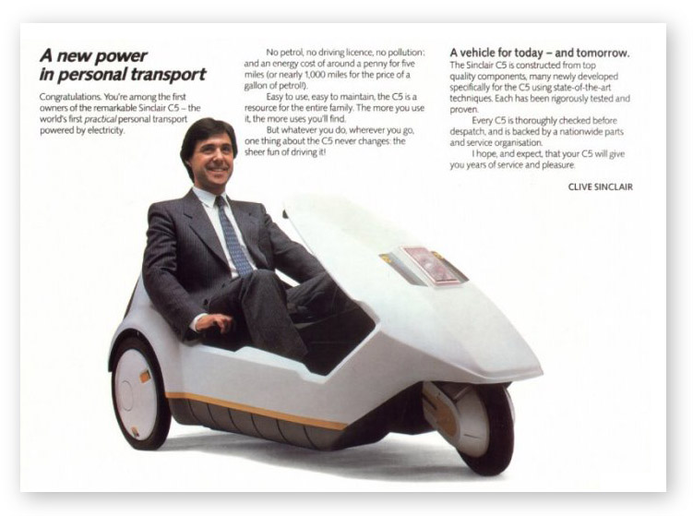
The Sinclair C5 was a battery electric vehicle launched in the United Kingdom in 1985. It was a battery-assisted tricycle, steered by handles on each side of the driver’s seat. Its top speed was 24km/h, which was the fastest allowed in the UK without a driver’s license. It became an object of popular ridicule and was a commercial disaster.
Problems…
- Cold weather shortened the battery life
- The motor overheated on hills
- The driver was exposed to British rain, sleet and snow
- Ridiculed for its unusual size and design
- Traffic visibility was poor
- Urban myth that the C5 was powered by a washing machine motor, because the motors were made by Italian company Polymotor

